**CHAPTER 1**

**<Times New Roman 14, Centre, All Caps, Bold>**

**INTRODUCTION**

**<Times New Roman 14, Centre, All Caps, Bold>**

**1.1 OVERVIEW <Times New Roman 12, All Caps>**

The Internet of Vehicles (IoV) is a distributed network that supports the use of data created by Connected cars and vehicular ad hoc networks (VANETs). An important goal of the IoV is to allow vehicles to communicate in real time with their human drivers, pedestrians, other vehicles, roadside infrastructure and systems. The technological revolution of our age impacts all industries. The desire for more intelligent and connected devices keeps growing. That’s why the Internet of Things is now all around us. In fact, it’s forecasted that the number of IoT connected devices will [reach 64 billion](https://www.businessinsider.com/internet-of-things-report) by 2025, up from 10 billion in 2018. It empowers physical objects with the ability to communicate and interact with each other. <Times New Roman 12, 1.5 Space, Justified, Paragraph style>

The cities are also becoming smarter and more connected. This will allow connected vehicles to slowly transform into autonomous ones, but none of this will be possible without a [new advanced network.](https://www.newequipment.com/industry-trends/importance-5g-auto-industry)

A key member, that is among the reasons for such rapid growth in the use of IoT devices is the Internet of Vehicles (IoV). It allows vehicles to exchange information, efficiency and most importantly safety with others as well as with infrastructures using Vehicular Ad Hoc Networks (VANETs), which originated from MANET or Mobile Ad-hoc Network.

The electronics used for that include infotainment systems, sensors, brakes, and GPS. There’s a clear need for better communication and interconnectivity between vehicles. As they’re turning into smart entities, cars are becoming an essential part of smart cities. TheIoV makes car sensor platforms, which absorb information from the environment, other vehicles and from the driver. All this for safer navigation, traffic management, and pollution control.

The Internet of Vehicles is a network of cars communicating with each other and with pedestrian's handheld devices, roadside units (RSUs) and public networks using vehicle-to-vehicle (V2V), vehicle-to-road (V2R), vehicle-to-human (V2H) and vehicle-to-sensor (V2S) interconnectivity. This creates a network with intelligent devices as participants.

* **Future of the IoV**

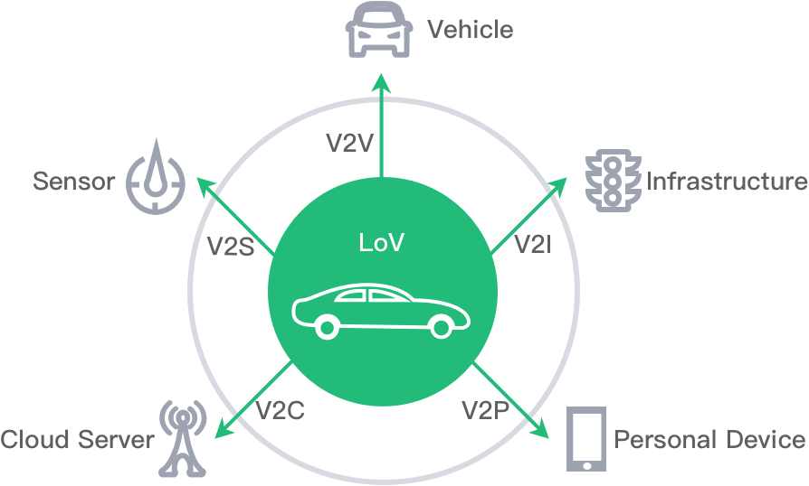According to a recent report by Allied Market Research, the global IoV market is expected to be over $200 billion by 2024 and several auto manufacturers, including BMW and Daimler, have announced programs to develop a platform that will connect IoV services like route management and smart parking with onboard infotainment centers.

**Figure 1.1 Internet of Vehicle Infrastructure**

**<Times New Roman, 12, Bold, Below the figure>**

As shown in figure 1.1, <All figures must be referred inside the text> the IoV supports the following five types of network communication:

1. **Vehicle to Sensors (V2S) -** Intra-Vehicle Systems that monitor the vehicle's internal performance through the sensors of **On Board Units (**[**OBUs**](https://whatis.techtarget.com/definition/on-board-diagnostics-OBD)**).**
2. **Vehicle to Vehicle (**[**V2V**](https://internetofthingsagenda.techtarget.com/definition/vehicle-to-vehicle-communication-V2V-communication)**) -** Systems that support the wireless exchange of information about the speed and position of surrounding vehicles.
3. **Vehicle to Infrastructure (V2I)**- Systems that support the wireless exchange of information between a vehicle and supporting roadside units (RSUs).
4. **Vehicle to Cloud (V2C)**- Systems that allow the vehicle to access additional information from the internet through application program interfaces ([APIs](https://searchapparchitecture.techtarget.com/definition/application-program-interface-API)).
5. **Vehicle to Pedestrian (V2P) -**Systems that support awareness for Vulnerable Road Users (VRUs) such as pedestrians and cyclists by communicating to the personal devices.

**1.2 OBJECTIVE**

The objective of project is to prevent or reduce the number of accidents happening due to over speeding or due to bad driving behavior by live tacking of vehicle and sending warning messages to the mobile devices. The data will also be used to rate the driver which will help in achieving better driving behavior from the driver.

This Project is all about a system that will get the location of a vehicle through GPS and send it to the main processing system, where the location of the vehicle will be used to retrieve the corresponding speed limit of the road where the vehicle is there using google services and maps API.

This system also gives warning to drivers through Mobile App if driver crosses the speed limit and the speed limit violations will be sent to the server where it will be used as one of the factors to rate the driver’s driving behavior.

The overall function of the system is to provide an alert message to the driver through a mobile app and to give rating to the driver according to their violation limits and standard statistics about their driving behavior in various locations such as highways, bypass and local roads.

The main purpose of this project is to prevent or reduce the number of accidents happening due to over speeding or due to bad driving behavior by live tracking of vehicles and sending warning messages to the mobile devices and to rate the driver according to the driver behavior.

**1.3 CHALLENGES IN THE DOMAIN**

* **Location**

Location detection at remote locations becomes troublesome as GPS can’t detect the location with at most accuracy.

* **Network**

The next challenge is Network, as the mobile app requires network to access the location and send alert message if the driver crosses the speed limit but the network is not stable in every location which leads to a problem

* **Getting speed limit**

Getting speed limit from local roads or remote roads are not accurate which may cause a problem in detecting the actual speed limit of the location which leads to trouble in detecting violation

* **Emergency situation**

In Emergency situation if driver tends to drive fast it may mark him as a violator which is not true this situation can also cause some challenge in rating the driver.

* **Smart Phone**

The next challenge is if the driver is not able to afford a smartphone and he/she has only a basic set and thus the alert message from the mobile app developed can’t be reached which causes a major challenge to reach the driver if he exceeds the speed limit.

**1.4 MOTIVATION**

At present most of the fatal road accidents happen due to rash driving and over speeding. So, who is responsible for complaining, reporting and taking needful actions about this rash driving as common people won’t and can’t actually do anything?

So, the simple answer is this speed limit control system and driver behavior Analysis can cause a good impact on reducing the accident due to over speeding.

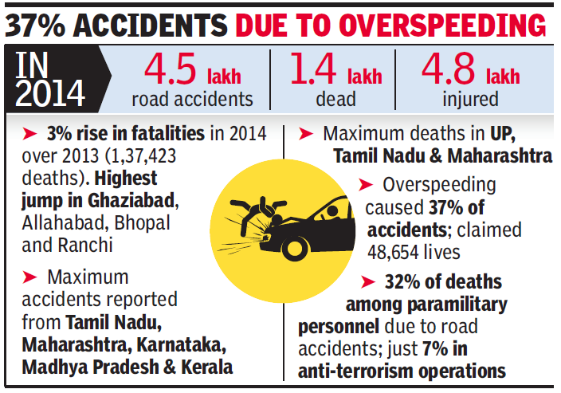

**Figure 1.2 Report on Number of Accidents**

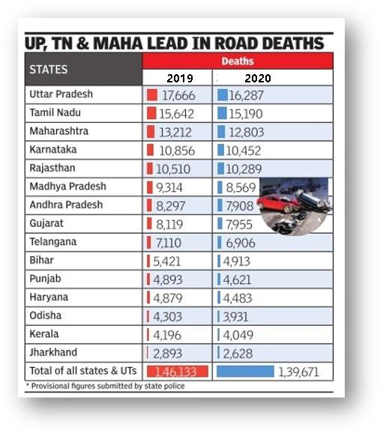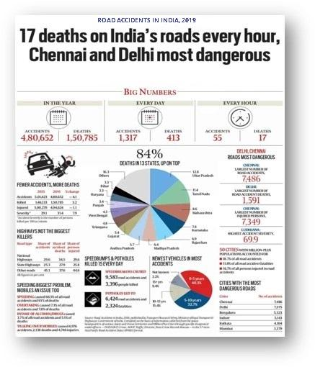

**Figure 1.3 Statistics of Road ccident Figure 1.4 Death Report**

As per the report shown in figure 1.2, nowadays 37% of the fatal road accidents happen due to rash driving and over speeding. So, who is responsible for complaining, reporting and taking needful actions about this rash driving as common people won’t and can’t actually do anything? So, the simple answer is this speed limit control system and driver behavior Analysis.

Figure 1.3shows that 17 deaths occur in India in every one hour due to rash driving. The rate of death due to rash driving as shown in figure 1.4 keeps on increasing with increase in population if there is no system to control or prevent it.

**1.5 ORGANIZATION OF THE REPORT**

This report is organized as follows: Chapter 1 consists of overview, objective and motivation about the project. Chapter 2 consists of the related works on the vehicle safety techniques, and other tools and methodology used to achieve it. Chapter 3 consists of the system analysis which defines the problem definition, various software components and use cases. The Chapter 4 describes the system design which consists of the system architecture for the proposed system and module description for each module. The Chapter 5 talks about the system implementation and the various algorithms. The Chapter 6 describes the system testing which consists of different test cases for the various modules. The Chapter 7 talks about the various results and discussion obtained from the various outputs. The Chapter 9 consists of conclusion and the future work for the project. The Appendix 1 consists of the Dart code and software implementations. The Appendix 2 consists of the screenshots of the various output screens. The Appendix 3 consists of the technical paper presentation and the references.